Marquette University
e-Publications@Marquette

Dentistry Faculty Research and Publications/School of Dentistry

This paper is NOT THE PUBLISHED VERSION.
Access the published version via the link in the citation below.

Journal of Oral and Maxillofacial Surgery, Vol. 76, No. 2 (February 2018): 368-373. DOI. This article is © Elsevier (WB Saunders) and permission has been granted for this version to appear in e-Publications@Marquette. Elsevier (WB Saunders) does not grant permission for this article to be further copied/distributed or hosted elsewhere without express permission from Elsevier (WB Saunders).

Giant Pilomatrix Carcinoma of the Face

Sapna Lohiya
Private Practice, Hermosa Beach, CA
Yeshwant B. Rawal
Department of Oral and Maxillofacial Surgery, School of Dentistry, University of Washington, Seattle, WA
Jasjit K. Dillon
Department of Oral and Maxillofacial Surgery, University of Washington, and Harborview Medical Center, Seattle, WA

This case report describes an unusually large facial pilomatrix carcinoma (PC) in a 60-year-old man. This PC had been growing slowly for 11 months and had recently ulcerated. It measured 9 cm × 7 cm × 5 cm. Initial punch biopsy findings were inconclusive. The tumor was excised in total with 5-mm margins in a supra-superficial musculoaponeurotic system plane. The defect was reconstructed with a cervicofacial bilobed rotational advancement flap. Histopathologic findings confirmed the diagnosis of PC. There was no lymph node spread or distant metastasis. The patient recovered with a good esthetic result. This case represents one of the largest facial PCs reported in the literature. Diagnostic challenges are discussed, and the literature is reviewed.

Pilomatrix carcinoma (PC) is a rare, low-grade malignancy derived from the hair matrix cells that produce the shaft and inner root sheaths of hair.¹ Fewer than 140 PC cases have been reported in the literature.² PCs can arise as solitary lesions de novo or through malignant transformation of benign pilomatrixomas. PCs occur 3 to 5 times more often in male patients and are seen mostly in the fourth to sixth decade of life. Over 50% of cases involve the head and neck, but PCs have also been described on the extremities, trunk, and genitalia.2, 3 The tumors usually present as small, solitary, ulcerated, or fungating nodules of long duration.⁴ Regional lymph node involvement is almost always associated with metastasis and thereby precludes curative management.² Without lymphatic involvement, wide local excision of the tumor is the treatment of choice with consideration of adjuvant radiation therapy.³
The diagnosis of PC is challenging because it can be readily confused with pilomatrixoma and other tumors. We describe a patient with a giant facial PC in whom preoperative punch biopsy findings were inconclusive. The correct diagnosis was made only after histopathologic examination of the entire excised tumor. We also review the literature.

Case Report
A 60-year-old white patient presented to the Harborview Medical Center's oral and maxillofacial surgery service with a left-sided facial tumor of 11 months' duration. As per the patient's report, the tumor was slow growing, minimally painful, and pruritic. It had recently ulcerated and would bleed upon direct irritation. The patient denied any recent weight loss, asthenia, dysphagia, dyspnea, fever, chills, or chest pain. His relevant medical history included hypertension and obesity. He was homeless. He used marijuana daily but did not use any tobacco products. His family history was notable for throat cancer and melanoma.
On examination, the patient had an ulcerated tumor on the lower left side of his face, measuring 9 cm × 7 cm × 5 cm (Fig 1). The tumor was firm, minimally tender, and adherent to skin but freely movable over the underlying tissues. Facial nerve function was intact. The patient's blood count and metabolic panel values were normal. Differential diagnoses included pilomatrixoma, basal cell or squamous cell carcinoma, and salivary gland or hair follicle tumors. Multiple punch biopsy specimens were obtained from the non-ulcerated parts of the tumor; this procedure was performed with local anesthesia. The histopathologic diagnosis was atypical benign pilomatrical neoplasm. Because of the tumor's relatively large size and the presence of mitotic activity and focal necrosis, PC could not be excluded. Surgical excision was recommended for final diagnosis.
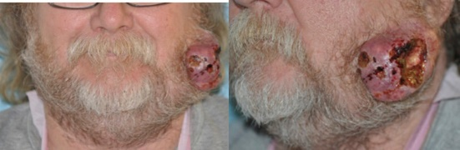
Figure 1. Ulcerated mass of lower left face, measuring 9 cm × 7 cm × 5 cm.

A computed tomography scan was obtained for surgical planning. It confirmed a large heterogeneous tumor arising from the left cheek tissue with thickening of the underlying platysma (Fig 2). Several morphologically abnormal lymph nodes—but no pathologically enlarged lymph nodes—were visualized.
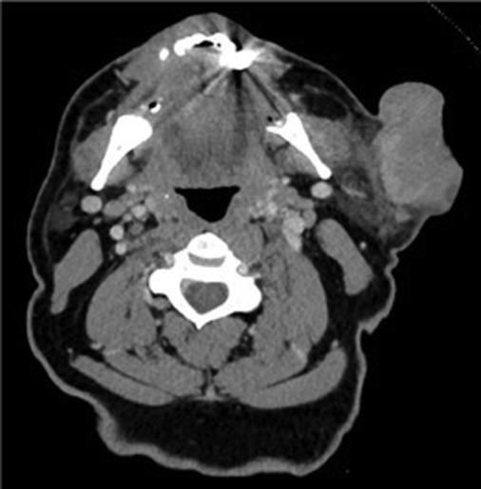
Figure 2. Computed tomography scan (axial cut, soft tissue window) showing large heterogeneous mass of left cheek, with thickening of underlying platysma.

On day 0, the patient underwent wide local excision of the tumor with 5-mm tissue margins, lymph node dissection, and reconstruction with a cervicofacial bilobed rotational advancement flap. The tumor was dissected in a supra-superficial musculoaponeurotic system plane (Fig 3). Dissection was continued in a postauricular manner and inferiorly to the level of the clavicle in a subplatysmal plane (Fig 4). The platysma muscle was included to ensure adequate blood supply to the flap, and the external jugular vein was preserved for improved venous drainage. Two prominent lymph nodes were removed, and the results of their frozen sections were negative for malignancy. The excised tumor was submitted in its entirety for histopathologic examination. A Jackson-Pratt drain was inserted, and tissues were reapproximated in a tension-free closure (Fig 5). The patient was monitored postoperatively for drain care. Initially, the flap appeared dusky at its most superior wound margin, but this potential vascular compromise resolved over the next 2 days. On day 4, the drain was removed and the patient was discharged. On day 10, the patient returned for follow-up and was doing well, without wound dehiscence, facial palsy, or flap failure (Fig 6).
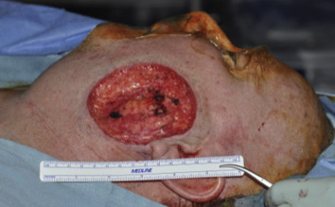
Figure 3. The final defect to be reconstructed measured 10 cm × 8 cm in the vertical and horizontal dimensions.

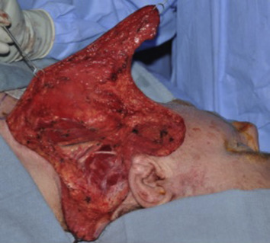
Figure 4. Cervicofacial flap raised to level of clavicle with easy arc of rotation into defect site.
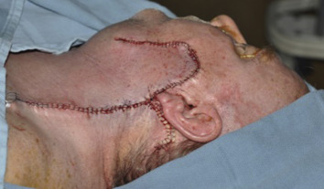
Figure 5. Tension-free closure achieved with cervicofacial bilobed rotational advancement flap.
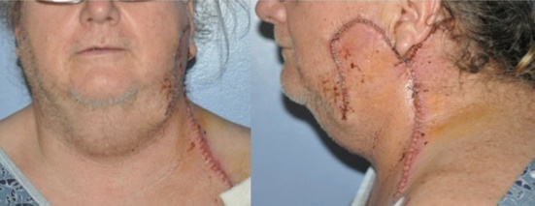
Figure 6. Uneventful postoperative healing on postoperative day 10.

Histopathologic examination of the excised tumor indicated a diagnosis of PC. The tumor was of hair matrix differentiation, composed of small darkly staining basaloid cells admixed with sheets of eosinophilic shadow (ghost) cells. A granulomatous foreign-body response to free keratin was prominent (Fig 7), and mitotic activity was brisk among the basaloid cells (Fig 8). Several foci of metaplastic calcification were seen within the tumor. Infiltrating nests of tumor cells evoked a stromal desmoplastic response (Fig 9). The tumor invaded subcutaneous tissue and fat (Fig 10), and areas of necrosis were seen (Fig 11). Lymphatic, vascular, or perineural spread was not detected. Malignant tissue was within 1 mm of one deep margin; the other surgical margins were widely tumor free.
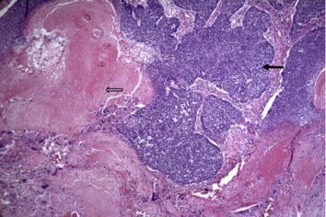
Figure 7. Biphasic tumor composed of small darkly staining basaloid cells (black arrow) and eosinophilic shadow (“ghost”) cells (open arrow). A granulomatous response to keratin is seen toward the lower left of the image (hematoxylin-eosin stain, original magnification ×4).
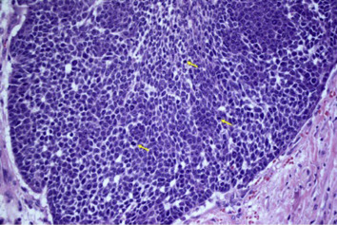
Figure 8. Basaloid cells show conspicuous mitoses (arrows) (hematoxylin-eosin stain, original magnification ×10).
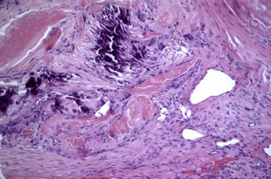
Figure 9. The tumor shows metaplastic calcification, a granulomatous response to keratin, and stromal desmoplasia (hematoxylin-eosin stain, original magnification ×10).
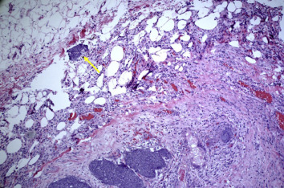
Figure 10. Tumor infiltrating into surrounding subcutaneous tissue and fat (arrow) (hematoxylin-eosin stain, original magnification ×4).
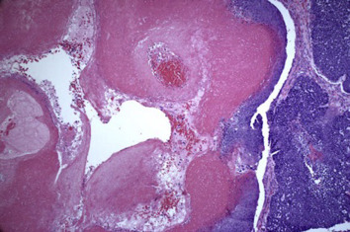
Figure 11. Tumor necrosis, cystic degeneration, and hemorrhage are visualized (hematoxylin-eosin stain, original magnification ×4).

This case was presented at our institution's multidisciplinary tumor board. Because of the one close margin and the high recurrence rate associated with PCs, adjunctive radiation therapy was recommended. This patient, however, was lost to follow-up.

Discussion
This case illustrates the diagnostic challenges clinicians can encounter with a PC case. On clinical examination, painless slow-growing PCs can be readily mistaken for benign pilomatrixomas, sebaceous cysts, epidermoid cysts, calcifying hematomas, or other hair follicle tumors such as trichoblastomas, trichilemmal carcinomas, trichoblastic carcinomas, and malignant proliferating trichilemmal tumors.4, 5 Most PCs are 1 to 10 cm in size; however, larger PCs have occasionally been seen.⁶ The largest PC described in the literature was on the posterior neck and measured 20 cm × 15 cm × 8 cm.⁷ To our knowledge, our patient's PC, measuring 9 cm × 7 cm × 5 cm, is the largest reported facial PC. These tumors are most often seen in 40- to 60-year-old male patients; however, occurrences of PCs in an 8-year-old girl and an 84-year-old man also have been reported.8, 9
PCs can be diagnostic challenges even after limited biopsy. Punch biopsy specimens may miss cancer because of limited tissue sampling, as in this case. We still suspected PC because of the tumor's large size, ulceration, and presence of mitotic activity and focal necrosis; these features caused us to excise the tumor with 5-mm margins. The histopathologic diagnosis of the final specimen was PC. The hallmarks of PC diagnosis are as follows: presence of hyperchromatic, vesicular basaloid cells with prominent nucleoli; atypical mitotic cells; necrosis; perineural or vascular invasion; central areas with keratotic material; ghost cells; and tumor nests surrounded by desmoplastic stroma. Immunohistochemical analyses of tumor markers to differentiate between benign and malignant pilomatrixomas have been unsuccessful.⁴
The PC recurrence rate is 64% with simple excision but falls to 21% with wide local excision. The literature contains reports of tumor excision with 5- to 30-mm margins.² With limited data, the current consensus for treatment is wide local excision of tumor with a minimum of 5-mm margins. Untreated PC can eventually invade deeper tissues and vital structures (eg, bone, eye, and brain). The literature reports metastasis in 16% of cases to the lungs, spine, and abdominal viscera.⁴
Radiation therapy has some utility as adjuvant therapy. It also may be used as primary treatment in cases in which surgery has been refused by the patient or is deemed too extensive and would negatively affect the patient's quality of life. The role of chemotherapy is less well understood; however, this modality in conjunction with radiation therapy continues to be used for metastatic disease treatment.¹⁰ Liu et al¹¹ used radiation therapy with no tumor recurrence during a 2-year follow-up in a patient in whom the tumor had recurred 4 times.
A report on PC is incomplete without a discussion of its 2 benign counterparts: pilomatrixomas and proliferating pilomatrixomas. Pilomatrixoma has a female predominance of 3:2 and a bimodal age distribution, with most cases occurring in children and in adults older than 50 years.³ The treatment is simple excision, and the recurrence rate is approximately 3%. Proliferating pilomatrixoma also has a female predominance; however, this entity occurs mostly in adults older than 60 years. It is more infiltrative in nature and has a recurrence rate of 14% after simple excision. PC differentiates itself from these variants with its male predominance, degree of histologic pleomorphism, increased recurrence rate, and presence of perineural and vascular invasion.
This PC case is unique because of its interesting presentation and diagnostic challenge. This report documents that in some cases, a PC can be diagnosed only by an excisional biopsy. PC treatment usually involves wide local excision of the tumor with a minimum of 5-mm margins and monitoring for recurrence. Closure of the skin defect with an advancement flap yields good esthetic results. Radiation therapy may be useful as an adjuvant to surgery or with chemotherapy for metastatic disease. As additional cases are reported in the literature, more definitive surgical guidelines can be made.

References
1 J. Sassmannshausen, M. Chaffins. Pilomatrix carcinoma: A report of a case arising from a previously excised pilomatrixoma and a review of the literature. J Am Acad Dermatol, 44 (2001), p. 358
2 C. Liu, M. Hoy, T. Matthews, et al. Pilomatrix carcinoma of the head and neck: Case report and literature review. Head Neck Oncol, 6 (2014), p. 12
3 D. Hardisson, M. Linares, J. Cuevas-Santos, et al. Pilomatrix carcinoma: A clinicopathologic study of six cases and review of the literature. Am J Dermatopathol, 23 (2001), p. 394
4 J. Alcantara-Gonzalez, M. Sanchez-Largo, A. Caminoa, et al. Pilomatrix carcinoma: A rare cause of facial tumor. Dermatol Online J, 20 (2014), p. 1
5 J. Glick, U. Alapati, A. Khachemoune. Pilomatrix carcinoma mimicking a pigmented basal cell carcinoma. Skinmed, 14 (2016), p. 475
6 P. LeBoit, G. Burg, D. Weedon, et al. World Health Organization Classification of Tumors. Pathology and Genetics of Skin Tumors. IARC Press, Lyon (2006)
7 L. Bridger, H. Koh, M. Smiddy, et al. Giant pilomatrix carcinoma: Report and review of the literature. J Am Acad Dermatol, 23 (1990), p. 985
8 E. Bailey, A. Rushovich, J. Kim. A growing nodule on the forearm of an 84-year-old man. J Cutan Pathol, 44 (2007), p. 1
9 M. Otero, C. Trujillo, R. Parra-Medina, et al. Metastatic malignant pilomatrixoma in an 8-year-old girl misdiagnosed as a recurrent pilomatrixoma. Am J Dermatopathol, 39 (2017), p. 41
10 K. Kim, M. Lee, Y. Kim, et al. Pilomatrix carcinoma with lung and lymph node metastases. J Lung Cancer, 7 (2008), p. 90
11 J. Liu, B. Li, Z. Fan, et al. Pilomatrix carcinoma on the left side of the parotid region: A case report and review of the literature. Oncol Lett, 10 (2015), p. 313

The University of Washington School of Dentistry Department of Oral and Maxillofacial Surgery's Laboratory for Applied Clinical Research and the Research and Training Fund supported, in part, preparation of this article.
Conflict of Interest Disclosures: Dr Dillon has received an Oral & Maxillofacial Surgery Foundation grant. All other authors do not have any relevant financial relationship(s) with a commercial interest.

